Pentagrammic Cuploid

Definition
# Source: AI Source: Provided by: [Data Path: Persons Table -> ID Column: 1, Name_En Column: Motasem Essam] -> From: [ChatGPT] on [7/25/2026]
A Pentagrammic Cuploid, also known as a $\{5/2\}$-Cuploid, is a specialized non-orientable polyhedral construction belonging to the cuploid family.
It is based on a five-pointed star (pentagram). It consists of triangular and square faces arranged around the star-shaped boundary. Its lower polygonal base is degenerate and is removed, so the triangular and square faces connect directly along the degenerate lower boundary.
A distinctive feature of this cuploid is a pentagram-shaped membrane that covers the region not filled by its lateral faces.
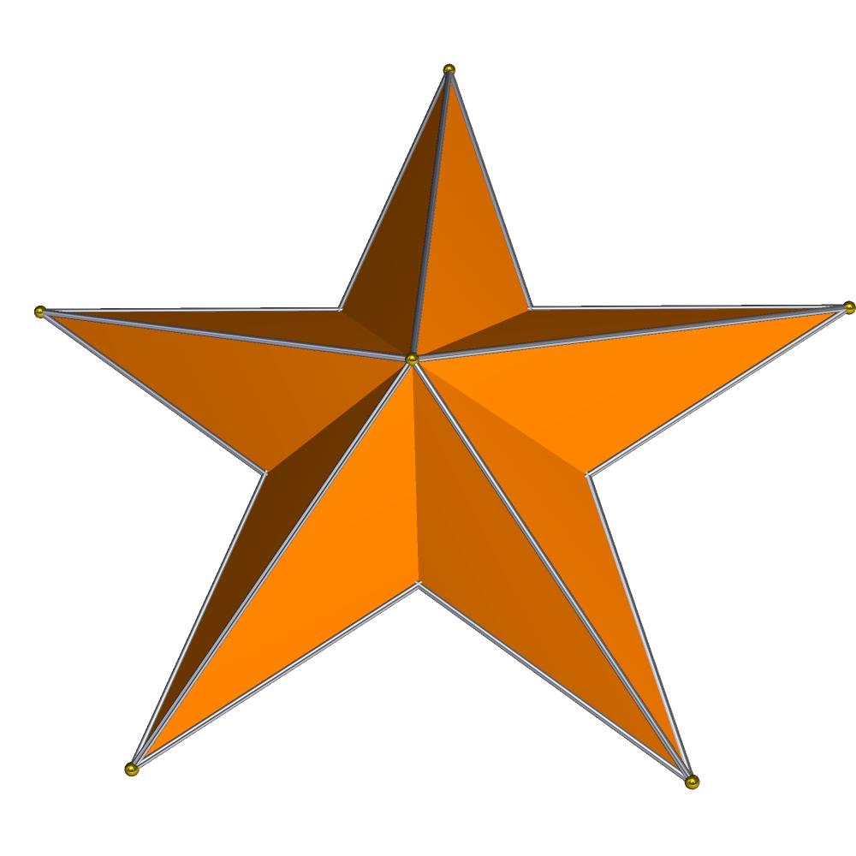

Simple Definition
# Source: AI Source: Provided by: [Data Path: Persons Table -> ID Column: 1, Name_En Column: Motasem Essam] -> From: [ChatGPT] on [7/25/2026]
A Pentagrammic Cuploid is a three-dimensional non-orientable geometric structure based on a five-pointed star, with five triangular faces, five square faces, and a pentagram-shaped membrane.

Geometric Structure
# Source: AI Source: Provided by: [Data Path: Persons Table -> ID Column: 1, Name_En Column: Motasem Essam] -> From: [ChatGPT] on [7/25/2026]
Its star-polygon notation is:
$$\boxed{\{5/2\}}$$
- 5 represents the five vertices of the star.
- 2 represents the step size used to connect the vertices.
- Connecting every vertex to the vertex two positions ahead produces a pentagram.
- The corresponding lower polygonal base is degenerate and is removed.
- Triangular and square faces connect directly along the resulting lower boundary.
- A pentagram-shaped membrane covers the remaining region.
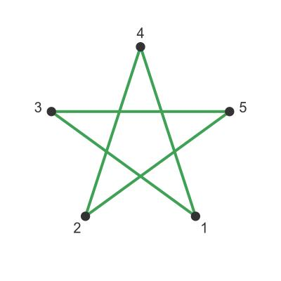

Face Structure
# Source: AI Source: Provided by: [Data Path: Persons Table -> ID Column: 1, Name_En Column: Motasem Essam] -> From: [ChatGPT] on [7/25/2026]
The standard Pentagrammic Cuploid has 11 faces, including its membrane:
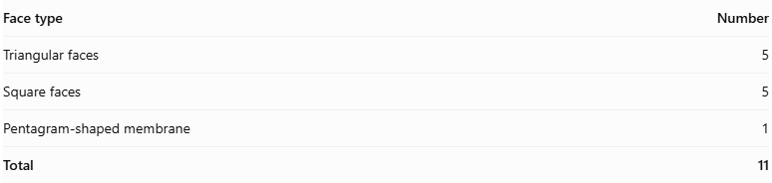
Face type | Number
Triangular faces | 5
Square faces | 5
Pentagram-shaped membrane | 1
Total | 11
The triangular and square faces form the lateral structure, while the membrane covers the central star-shaped region.
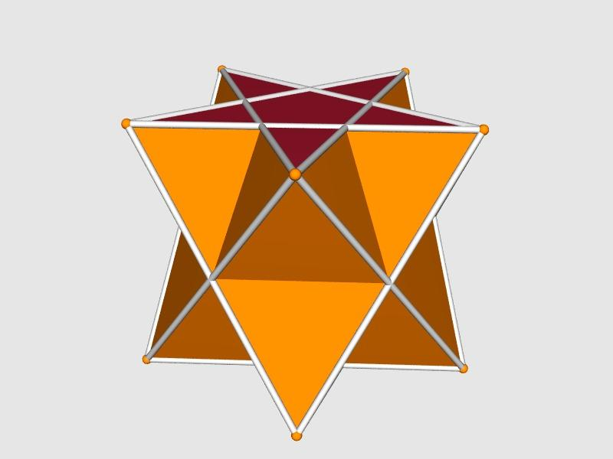

Edge Structure
# Source: AI Source: Provided by: [Data Path: Persons Table -> ID Column: 1, Name_En Column: Motasem Essam] -> From: [ChatGPT] on [7/25/2026]
The standard realization has 20 edges.
- The edges connect the triangular and square faces.
- The upper boundary follows a pentagram arrangement.
- Some connections follow the crossed geometry of the star polygon.
- The degenerate lower polygonal base is absent.

Vertex Structure
# Source: AI Source: Provided by: [Data Path: Persons Table -> ID Column: 1, Name_En Column: Motasem Essam] -> From: [ChatGPT] on [7/25/2026]
The standard realization has 10 vertices.
- Five vertices belong to the pentagram arrangement.
- The remaining vertices form the lower portions of the face structure.
- Vertices connect the triangular and square faces in a non-orientable arrangement.

Mathematical Properties
# Source: AI Source: Provided by: [Data Path: Persons Table -> ID Column: 1, Name_En Column: Motasem Essam] -> From: [ChatGPT] on [7/25/2026]
Geometric properties
11
Faces
20
Edges
10
Vertices
Euler characteristic:
$$V-E+F=10-20+11=1$$
This is consistent with a closed non-orientable surface.

Non-Orientability
# Source: AI Source: Provided by: [Data Path: Persons Table -> ID Column: 1, Name_En Column: Motasem Essam] -> From: [ChatGPT] on [7/25/2026]
The Pentagrammic Cuploid is non-orientable.
This means that its surface cannot be assigned a consistent global orientation. It does not have two globally distinguishable sides in the way an ordinary orientable polyhedral surface does.
Non-orientability is a topological property, not simply a result of the pentagram's crossed appearance.

The Pentagram-Shaped Membrane
# Source: AI Source: Provided by: [Data Path: Persons Table -> ID Column: 1, Name_En Column: Motasem Essam] -> From: [ChatGPT] on [7/25/2026]
The membrane is one of the most distinctive features of the Pentagrammic Cuploid.
- It occupies the central pentagram-shaped region.
- The lateral triangular and square faces do not completely cover this region.
- It completes the surface construction.
- It is not an ordinary solid-filled pentagonal base.
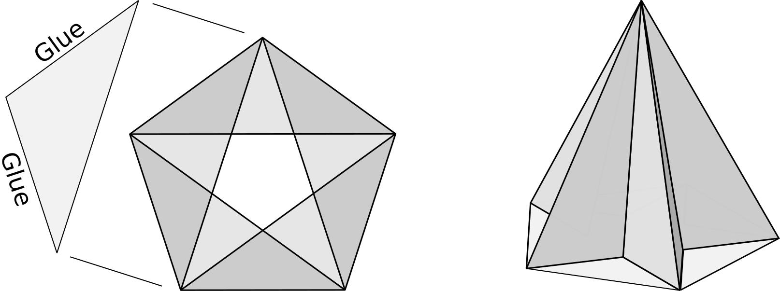

Vertex Configuration
# Source: AI Source: Provided by: [Data Path: Persons Table -> ID Column: 1, Name_En Column: Motasem Essam] -> From: [ChatGPT] on [7/25/2026]
The Pentagrammic Cuploid has two types of vertex configurations:
$$5(5/2.4.3.4)$$
$$5(3.4.3/2.4/3)$$
These describe how the faces meet around its ten vertices. The notation includes the pentagrammic face symbol $5/2$, square faces $4$, and triangular faces $3$.

Symmetry
# Source: AI Source: Provided by: [Data Path: Persons Table -> ID Column: 1, Name_En Column: Motasem Essam] -> From: [ChatGPT] on [7/25/2026]
The standard Pentagrammic Cuploid has:
- Fivefold rotational symmetry.
- Five vertical reflection planes.
- Symmetry group: $C_{5v}$.
- Rotation group: $C_{5}$.
These symmetries are associated with its regular pentagrammic arrangement.

Dual Polyhedron
# Source: AI Source: Provided by: [Data Path: Persons Table -> ID Column: 1, Name_En Column: Motasem Essam] -> From: [ChatGPT] on [7/25/2026]
The dual of the Pentagrammic Cuploid is called the Pentagrammic Keratinoid.
Its face structure consists of:
- Five kite-shaped faces.
- Five antiparallelogram-shaped faces.
The dual relationship exchanges vertices and faces while preserving their incidence relationships.
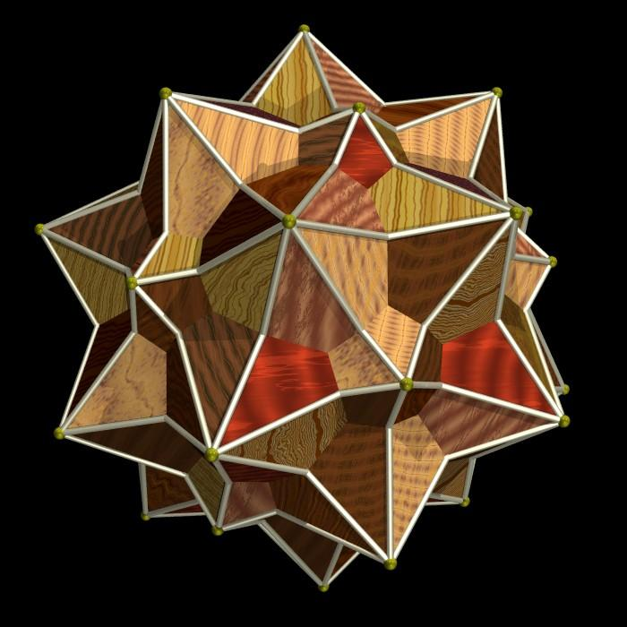

Construction of a Pentagrammic Cuploid

Geometric Instruments Used
# Source: AI Source: Provided by: [Data Path: Persons Table -> ID Column: 1, Name_En Column: Motasem Essam] -> From: [ChatGPT] on [7/25/2026]
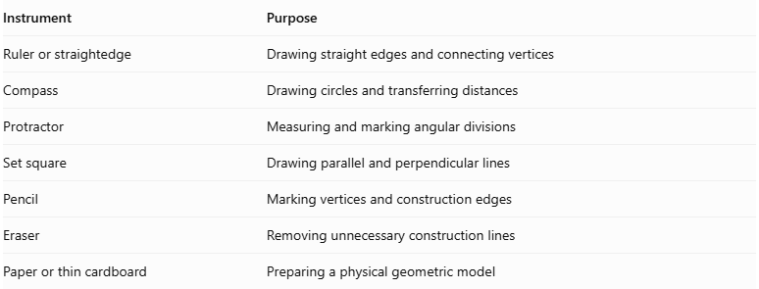
Instrument | Purpose
Ruler or straightedge | Drawing straight edges and connecting vertices
Compass | Drawing circles and transferring distances
Protractor | Measuring and marking angular divisions
Set square | Drawing parallel and perpendicular lines
Pencil | Marking vertices and construction edges
Eraser | Removing unnecessary construction lines
Paper or thin cardboard | Preparing a physical geometric model
Construction method: Instrument-based geometric construction using geometric instruments, angular measurements, and geometric relationships. It does not use coordinate-based construction.

Instrument-Based Construction Procedures

Constructing the Pentagram
# Source: AI Source: Provided by: [Data Path: Persons Table -> ID Column: 1, Name_En Column: Motasem Essam] -> From: [ChatGPT] on [7/25/2026]
- Draw a circle using a compass.
- Mark five equally spaced points around its circumference.
- Number the vertices consecutively from 1 to 5.
- Connect every vertex to the vertex two positions ahead.
- Follow the connection sequence:
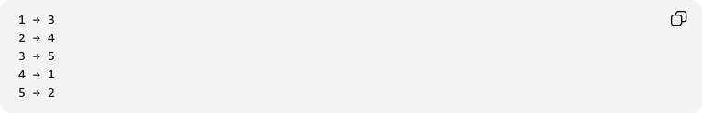
1 → 3
2 → 4
3 → 5
4 → 1
5 → 2
- Complete the pentagram $\{5/2\}$.

Preparing the Five Square Faces
# Source: AI Source: Provided by: [Data Path: Persons Table -> ID Column: 1, Name_En Column: Motasem Essam] -> From: [ChatGPT] on [7/25/2026]
- Identify the five principal vertex and edge regions of the pentagrammic arrangement.
- Mark the positions for the five square lateral faces.
- Construct the squares using the ruler and set square.
- Arrange them around the pentagrammic structure.
- Check that the square edges match the intended triangular-face connections.

Constructing the Five Triangular Faces
# Source: AI Source: Provided by: [Data Path: Persons Table -> ID Column: 1, Name_En Column: Motasem Essam] -> From: [ChatGPT] on [7/25/2026]
- Identify the five positions between the square faces.
- Construct five triangular faces.
- Use the appropriate concave orientation required by the cuploid structure.
- Connect each triangle to its neighboring square faces.
- Preserve the fivefold arrangement.

Connecting the Faces
# Source: AI Source: Provided by: [Data Path: Persons Table -> ID Column: 1, Name_En Column: Motasem Essam] -> From: [ChatGPT] on [7/25/2026]
- Connect the five square faces and five triangular faces according to the Pentagrammic Cuploid's face-adjacency structure.
- Attach the pentagrammic face to the appropriate boundary edges.
- Remove the degenerate coincident base representation from the construction.
- Connect the triangular and square faces directly along the resulting shared edges.
- Check that the intended model has no unintended gaps or additional face connections.

Completing the Three-Dimensional Representation
# Source: AI Source: Provided by: [Data Path: Persons Table -> ID Column: 1, Name_En Column: Motasem Essam] -> From: [ChatGPT] on [7/25/2026]
- Darken the visible edges.
- Use dashed lines for hidden edges where appropriate.
- Preserve the pentagrammic appearance.
- Check the fivefold rotational arrangement.
- Verify the five triangular faces and five square faces.
- Distinguish actual vertices from visual intersections of the star-polygon edges.
Construction accuracy note: The regular pentagon can be constructed exactly using a compass and unmarked straightedge. The pentagram is then produced by connecting every second vertex. The three-dimensional face arrangement must follow the cuploid topology rather than an ordinary pentagonal cupola net.

Key Points
# Source: AI Source: Provided by: [Data Path: Persons Table -> ID Column: 1, Name_En Column: Motasem Essam] -> From: [ChatGPT] on [7/25/2026]
- The Pentagrammic Cuploid is represented by $\{5/2\}$.
- It is also called the Pentagrammic Semicupola.
- It is based on a five-pointed star.
- It has five triangular faces.
- It has five square faces.
- It has one pentagram-shaped membrane.
- It has 11 faces, 20 edges, and 10 vertices.
- It is a non-orientable polyhedral surface.
- Its symmetry group is $C_{5v}$.
- Its dual is the Pentagrammic Keratinoid.

Conclusion
# Source: AI Source: Provided by: [Data Path: Persons Table -> ID Column: 1, Name_En Column: Motasem Essam] -> From: [ChatGPT] on [7/25/2026]
The Pentagrammic Cuploid is a specialized non-orientable polyhedral structure based on a five-pointed star. Its combination of triangular faces, square faces, and a pentagram-shaped membrane makes it a distinctive example of advanced solid geometry and polyhedral topology.

